Implement Using Interaction Diagram
K Vamsi-192372062

1. Develop a system using UML for Personal Loan Management
System
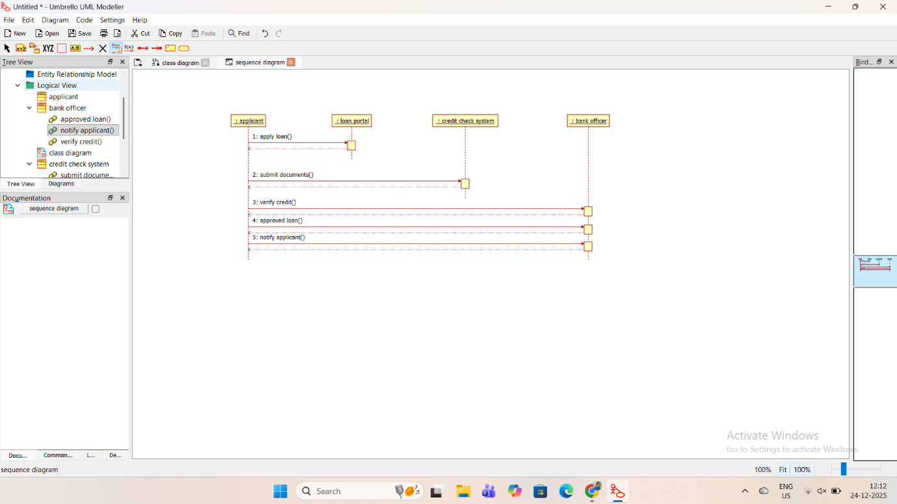
2. Develop a system using UML for Home Loan Management
System
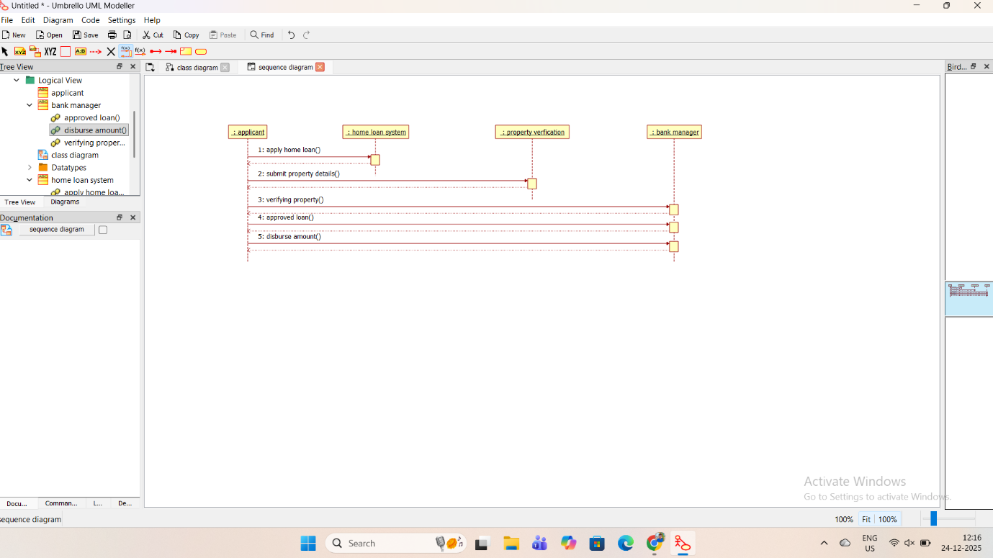

3. Develop a system using UML for Land Registration System
